**Ganpat University**

**Faculty of Engineering & Technology**

**Computer Science & Engineering**

**2CSE205: Computer Organization**

***Name:- Dwij Vatsal Desai***

***Sem:- 2***

***Sub: - ESFP-ll***

***Enrollment No.:- 23162121027***

***ESFP-II Assignment***

***Date:- 10/5/2024***

* ***All the questions answered (Because the progress is not show in graph)***

### **Chapter 1: Introduction to Programming Languages**

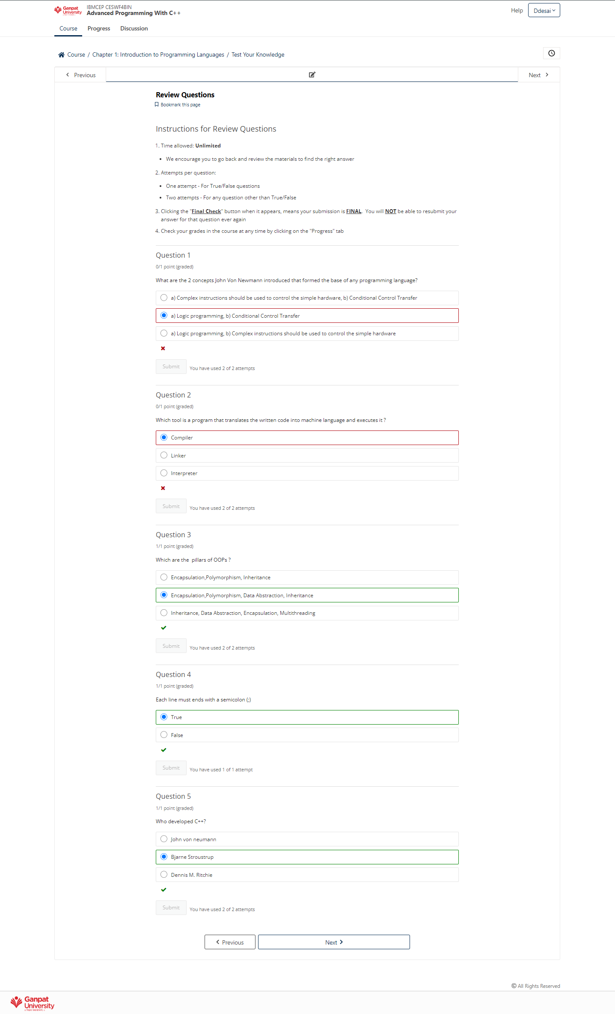

### **Chapter 2: Conditional Programming Constructs**

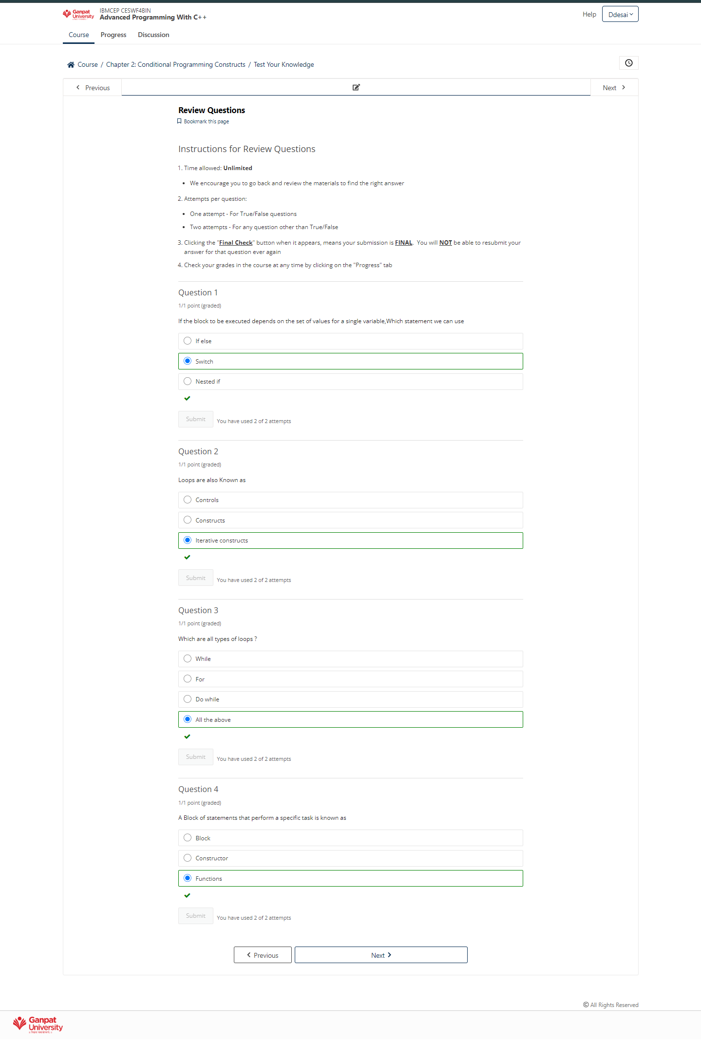

### **Chapter 3: Classes and Object**

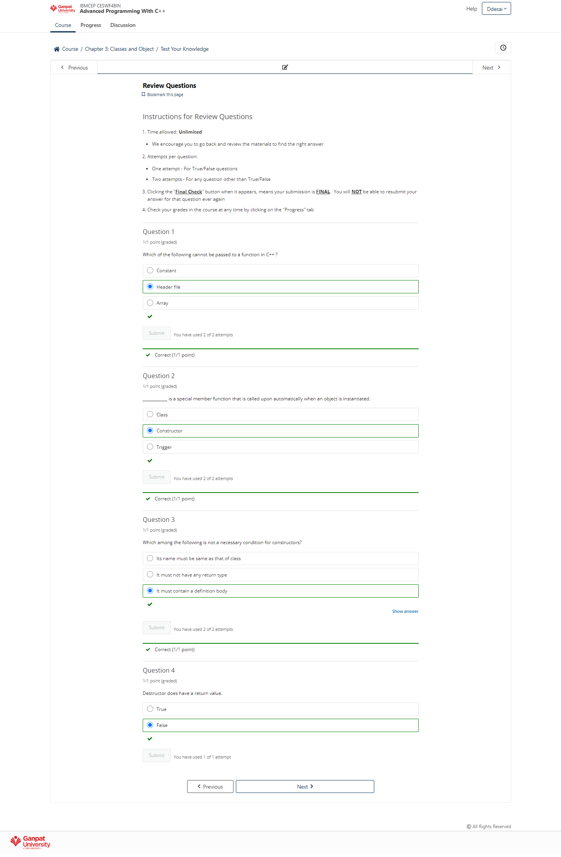

### **Chapter 4: Polymorphism, Inheritance and Encapsulation**

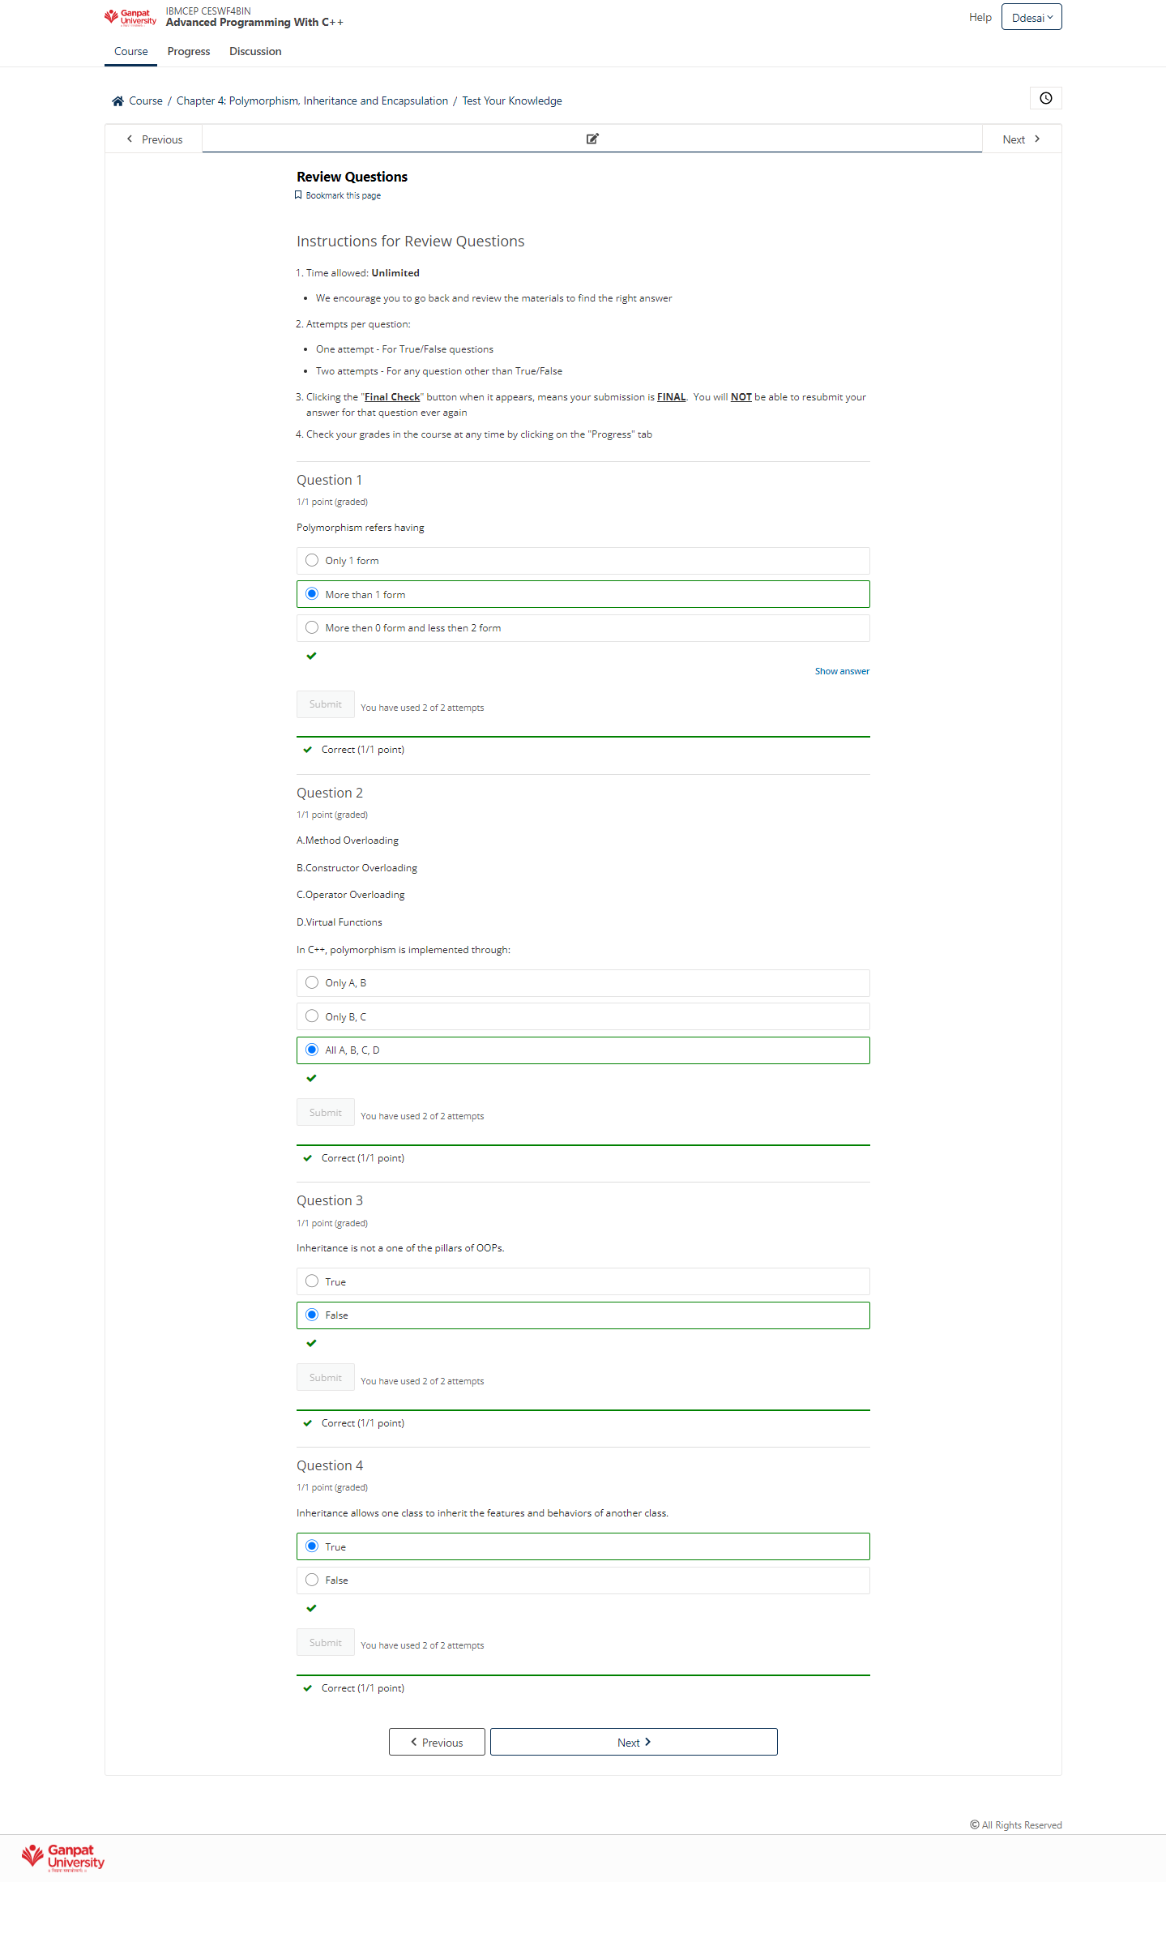

### **Chapter 5: Operator Overloading**

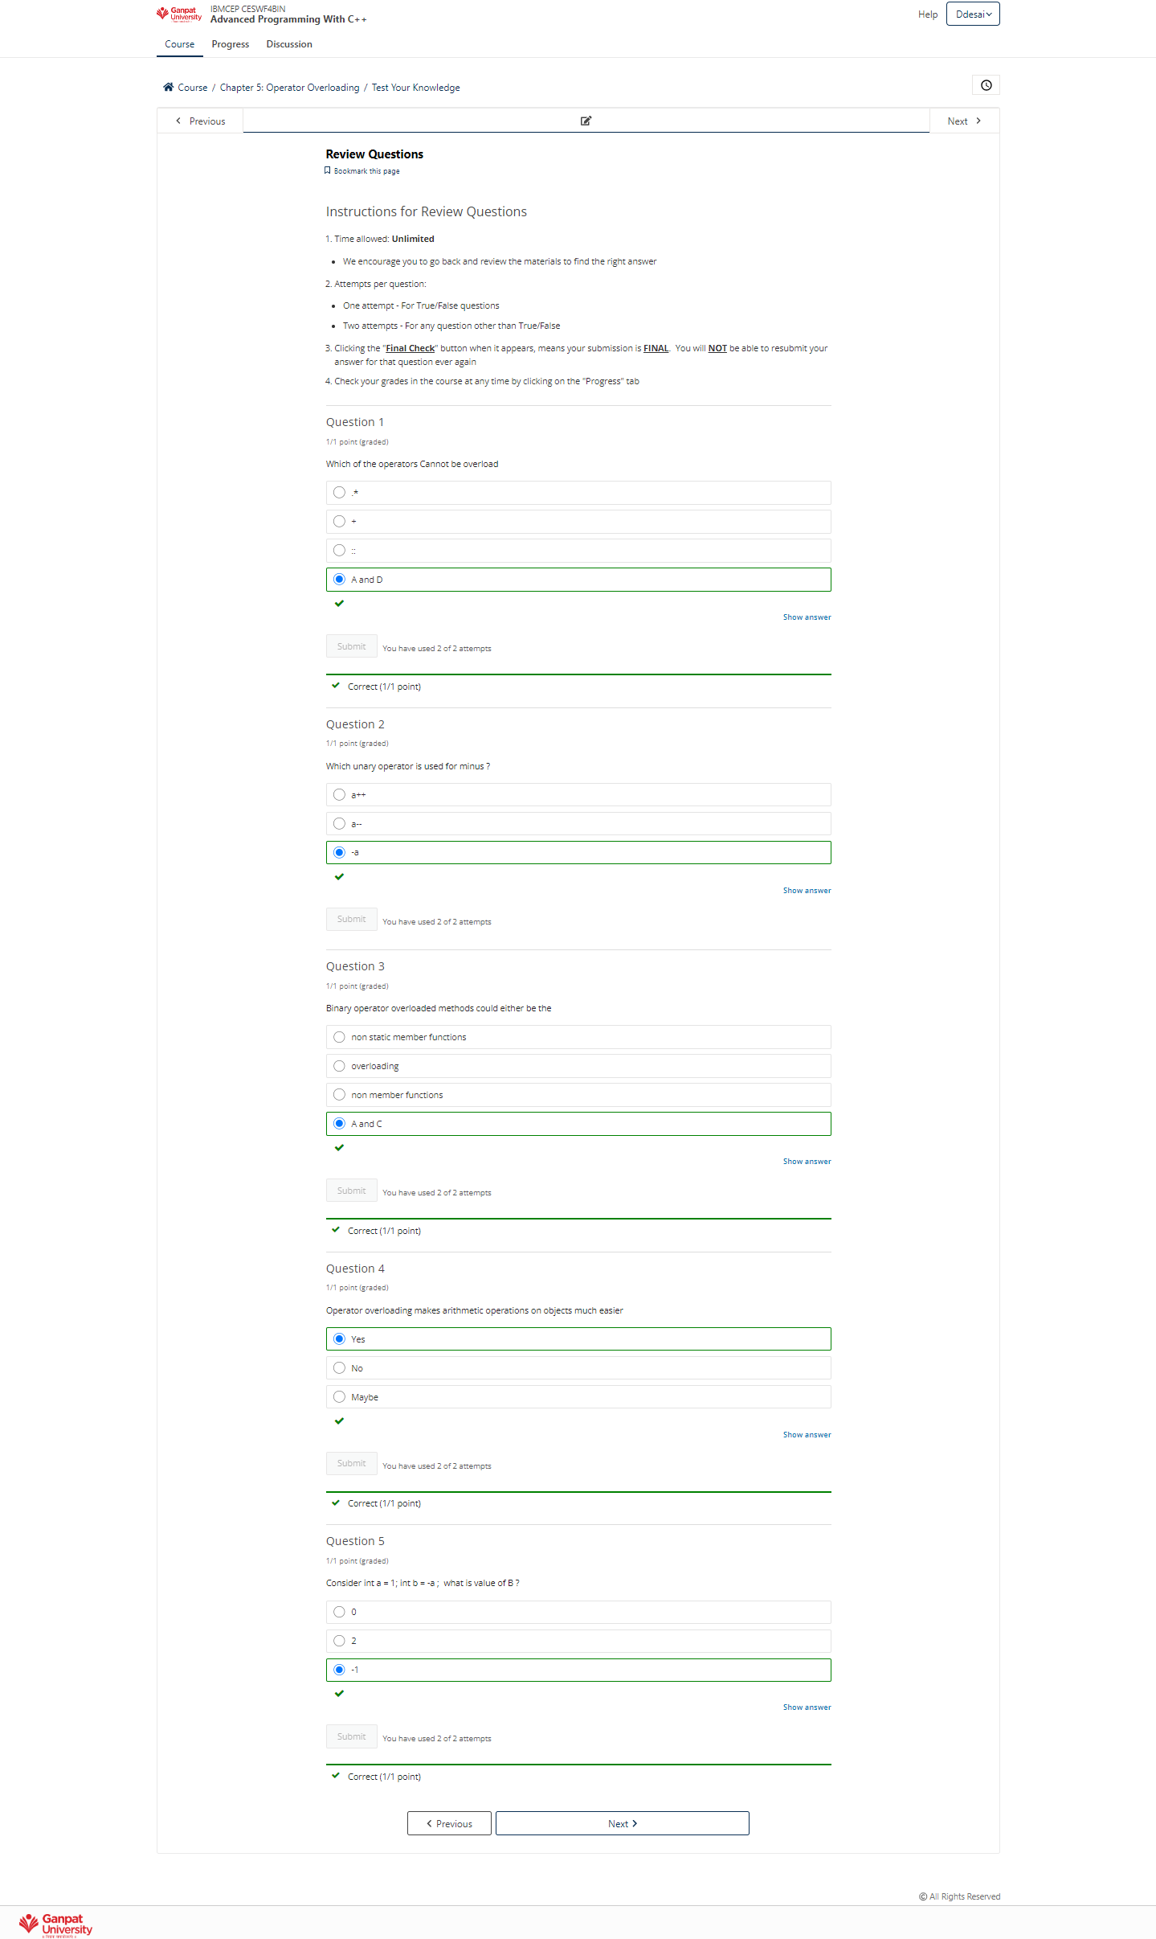

### **Chapter 6: File Handling**

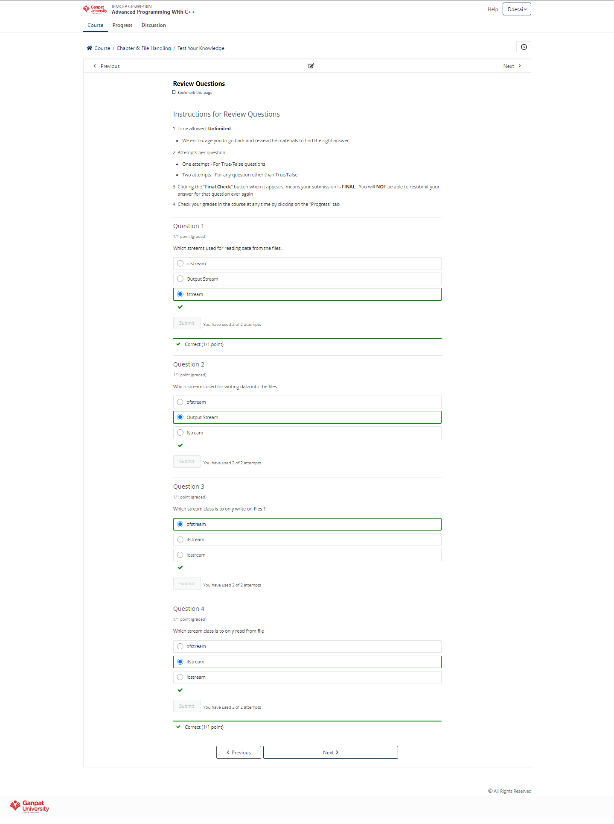

### **Chapter 7: Advanced Topics**

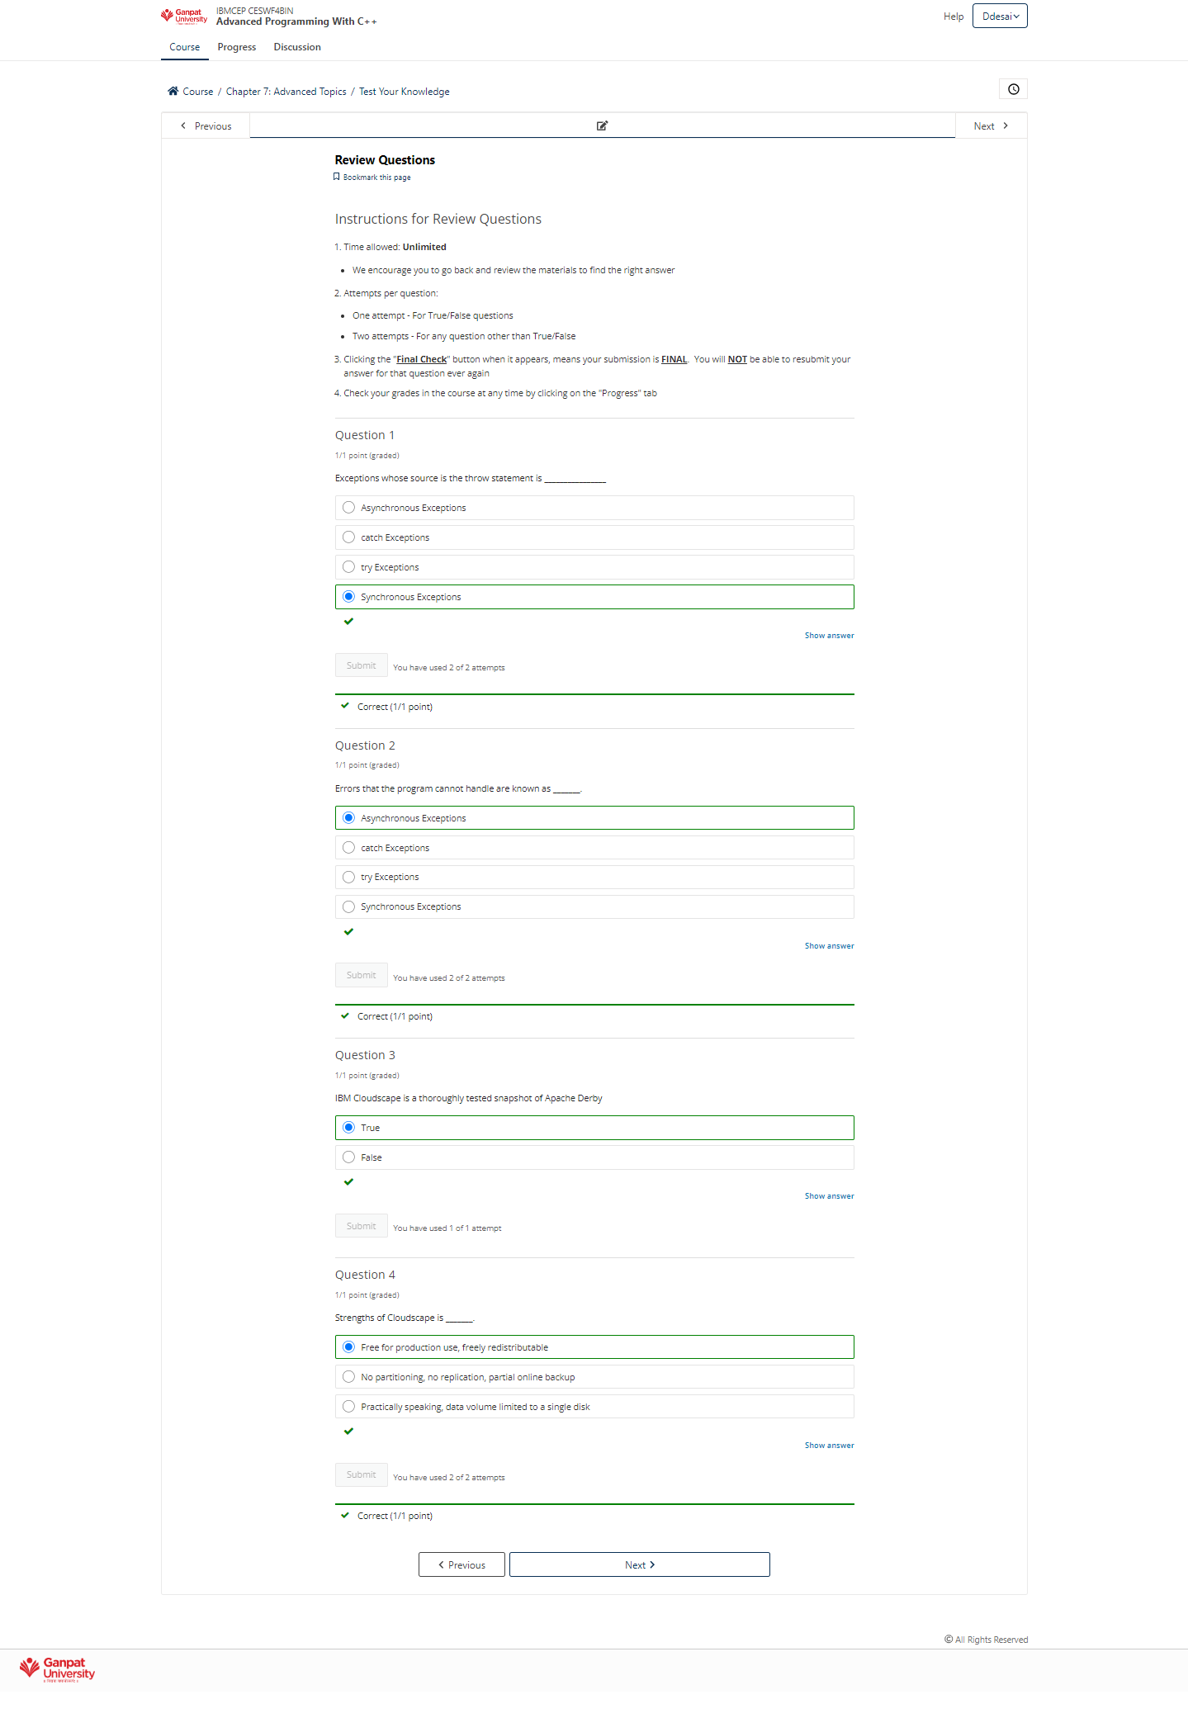

### **Chapter 8: XML**

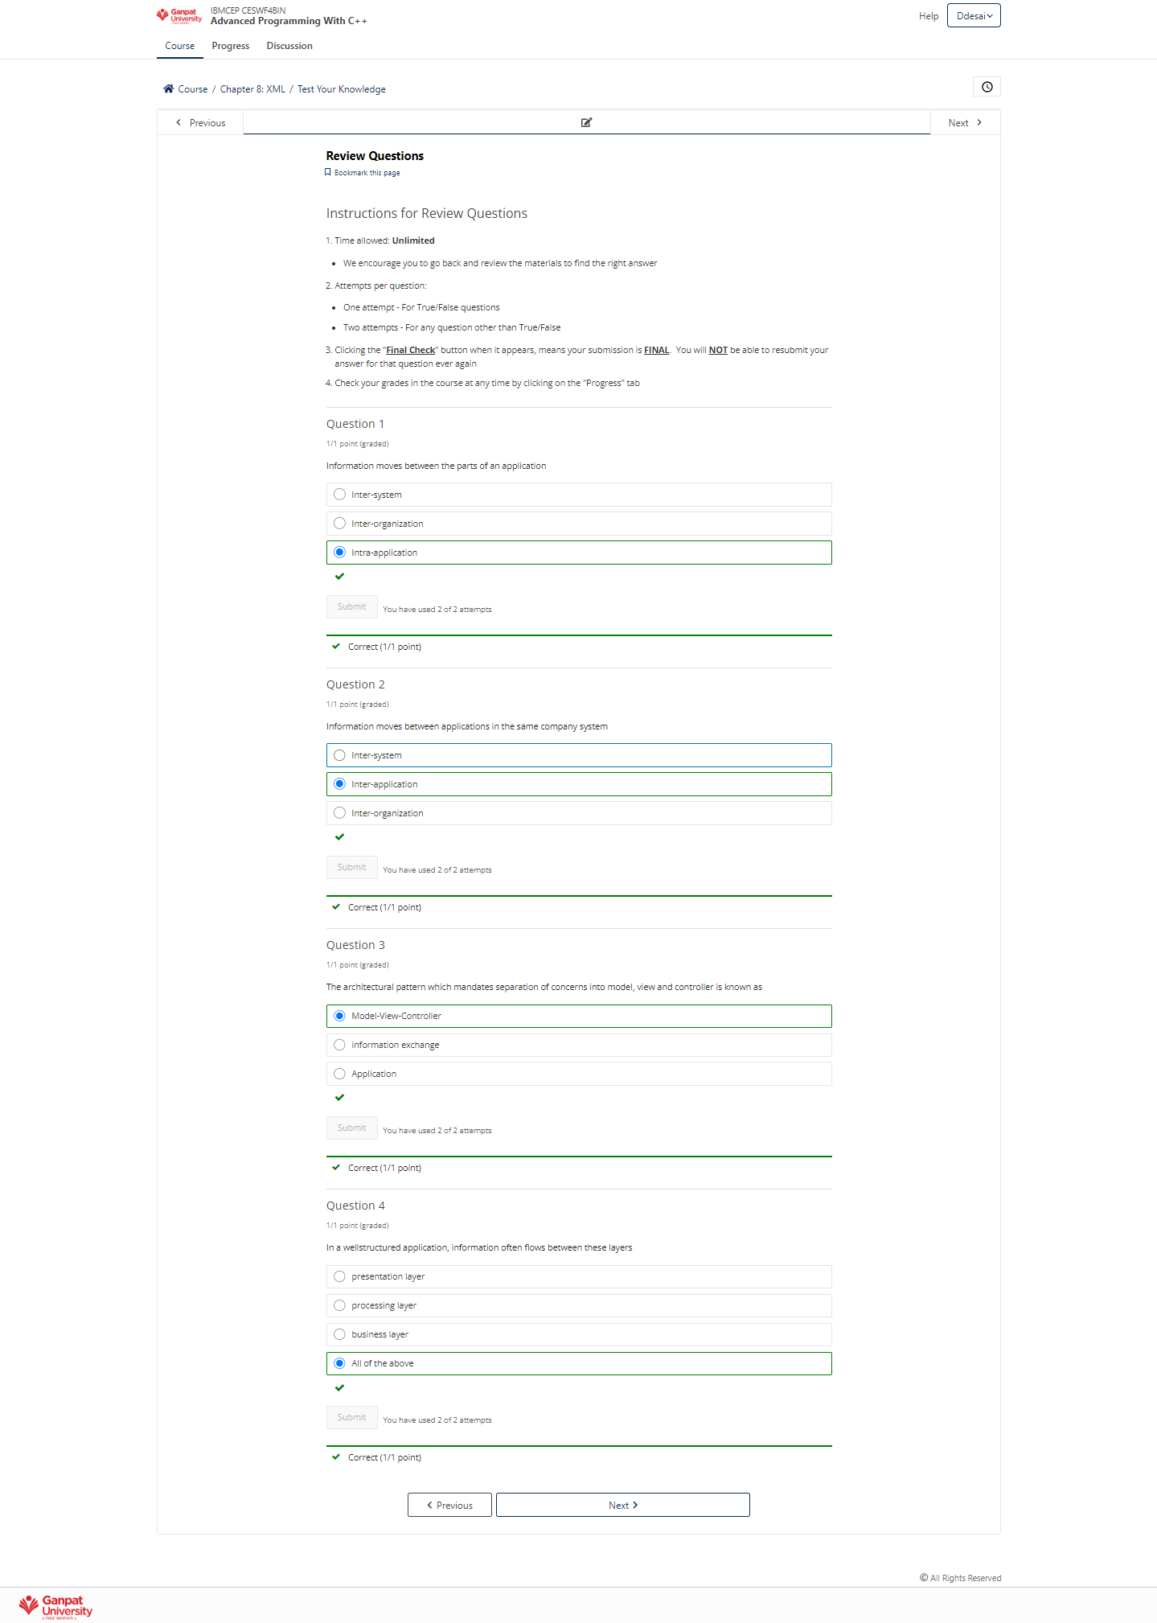

### **Chapter 9: Introduction to Eclipse**

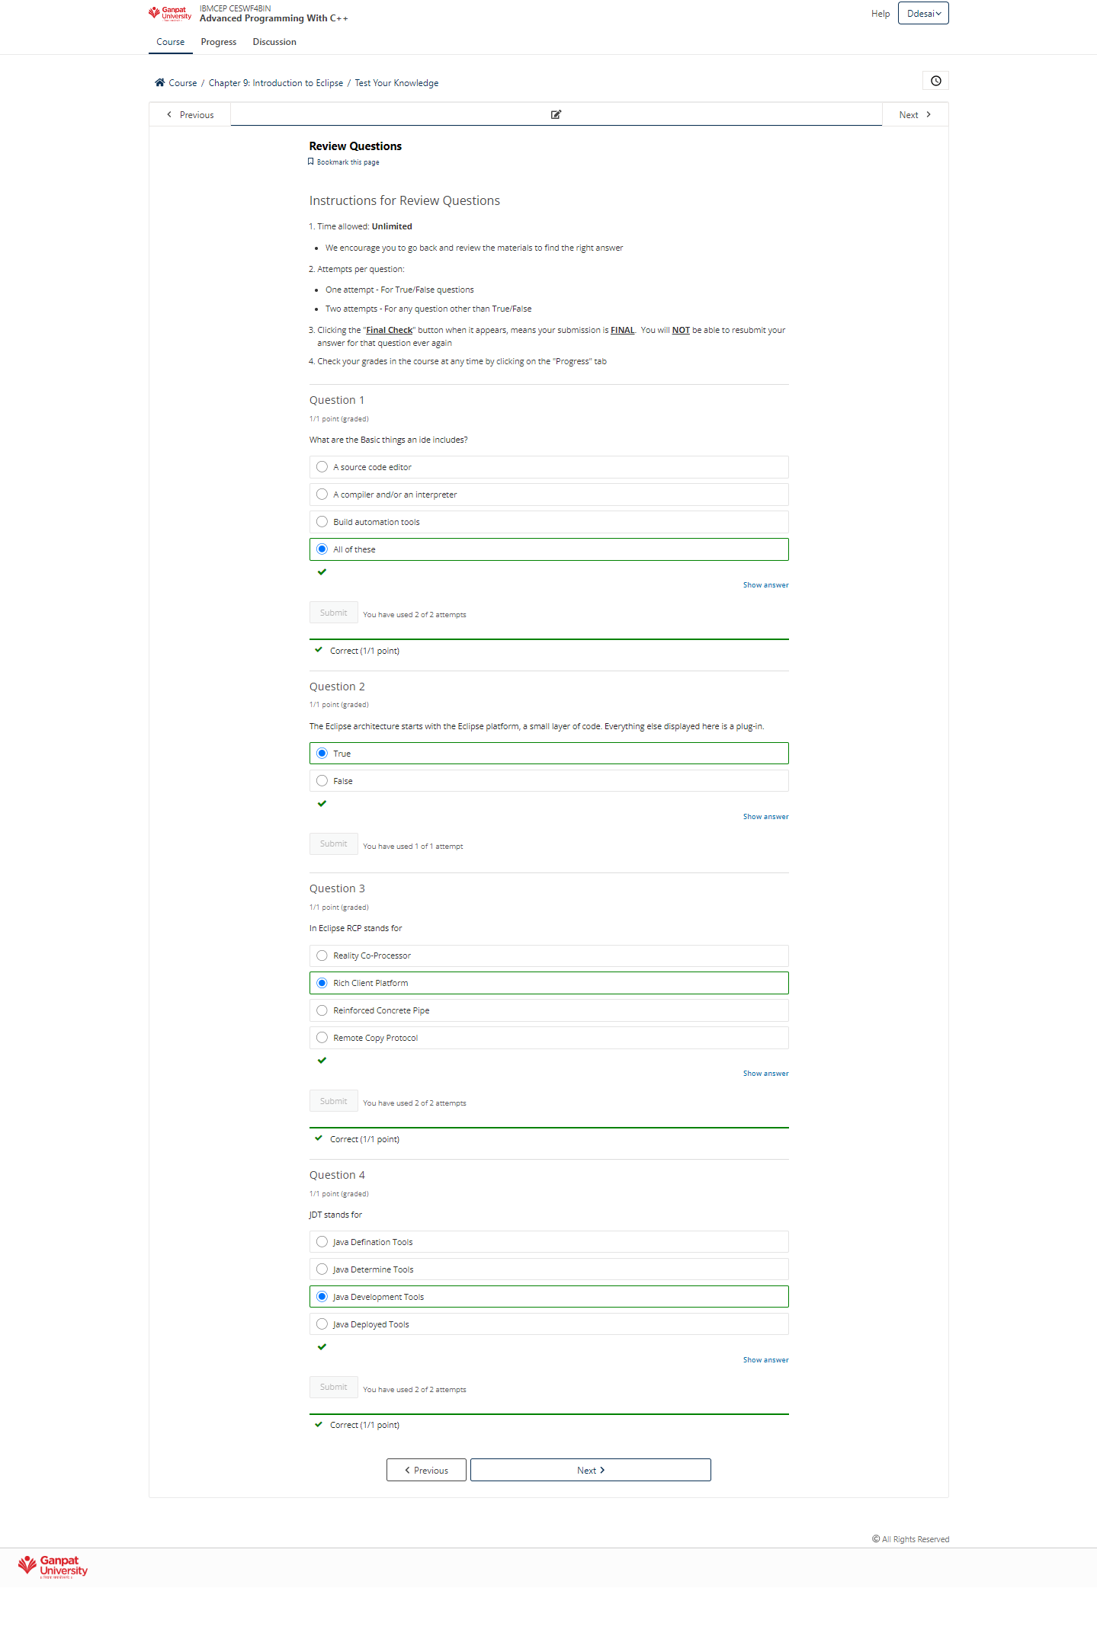

### **Chapter 10: Java Development Tools**

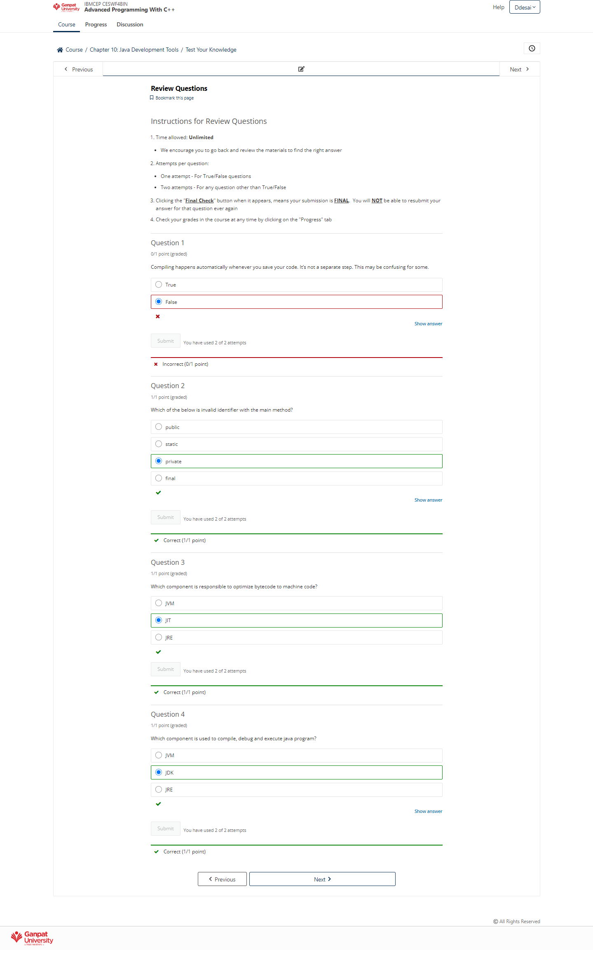

### **Chapter 11: The Eclipse Debugger**

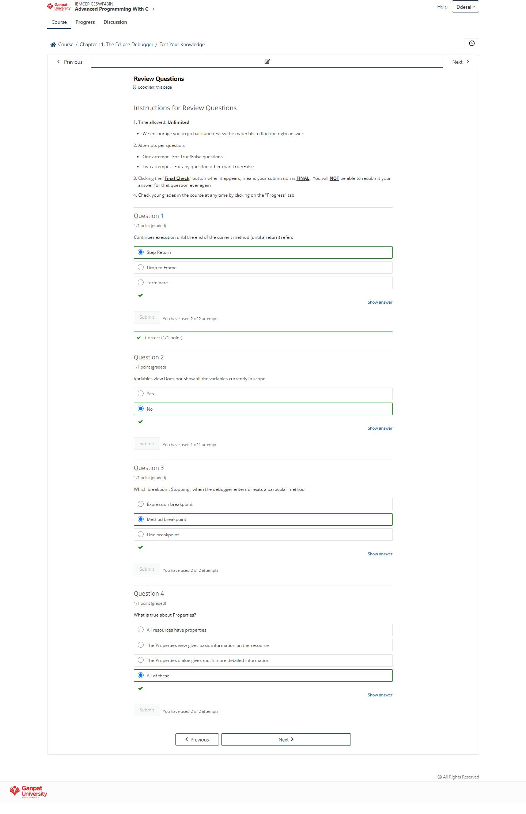

### **Chapter 12: The Eclips Plug-in Architecture**

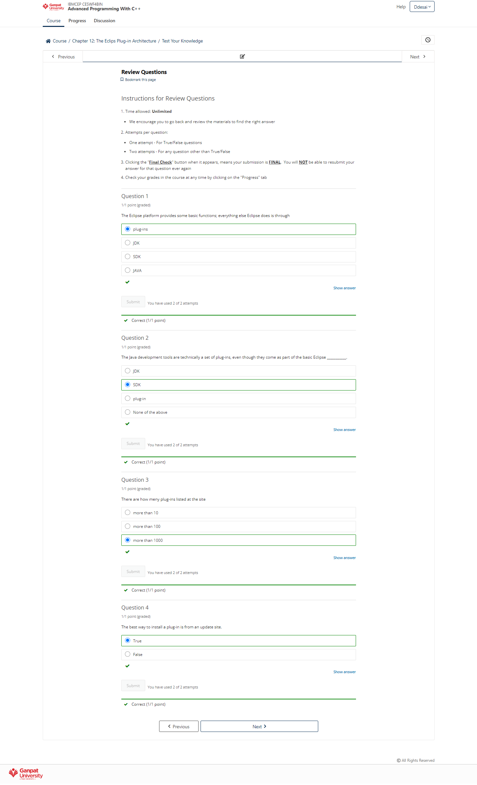

### **Chapter 13: Eclipse Web Tools Platform (and related tools)**

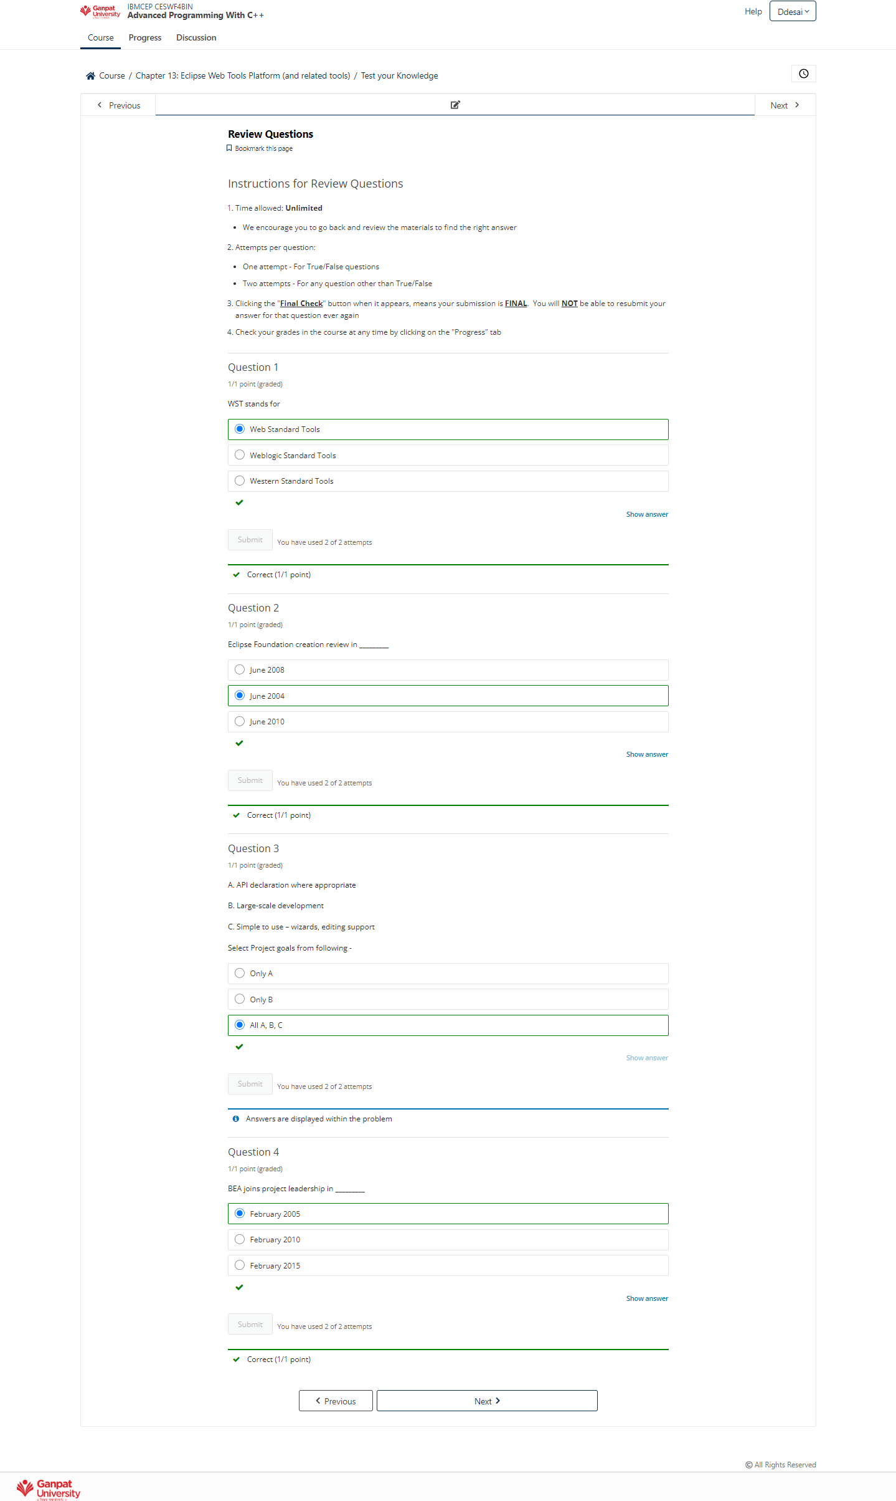

### **Chapter 14: Software in Real World - The IBM Canvas**

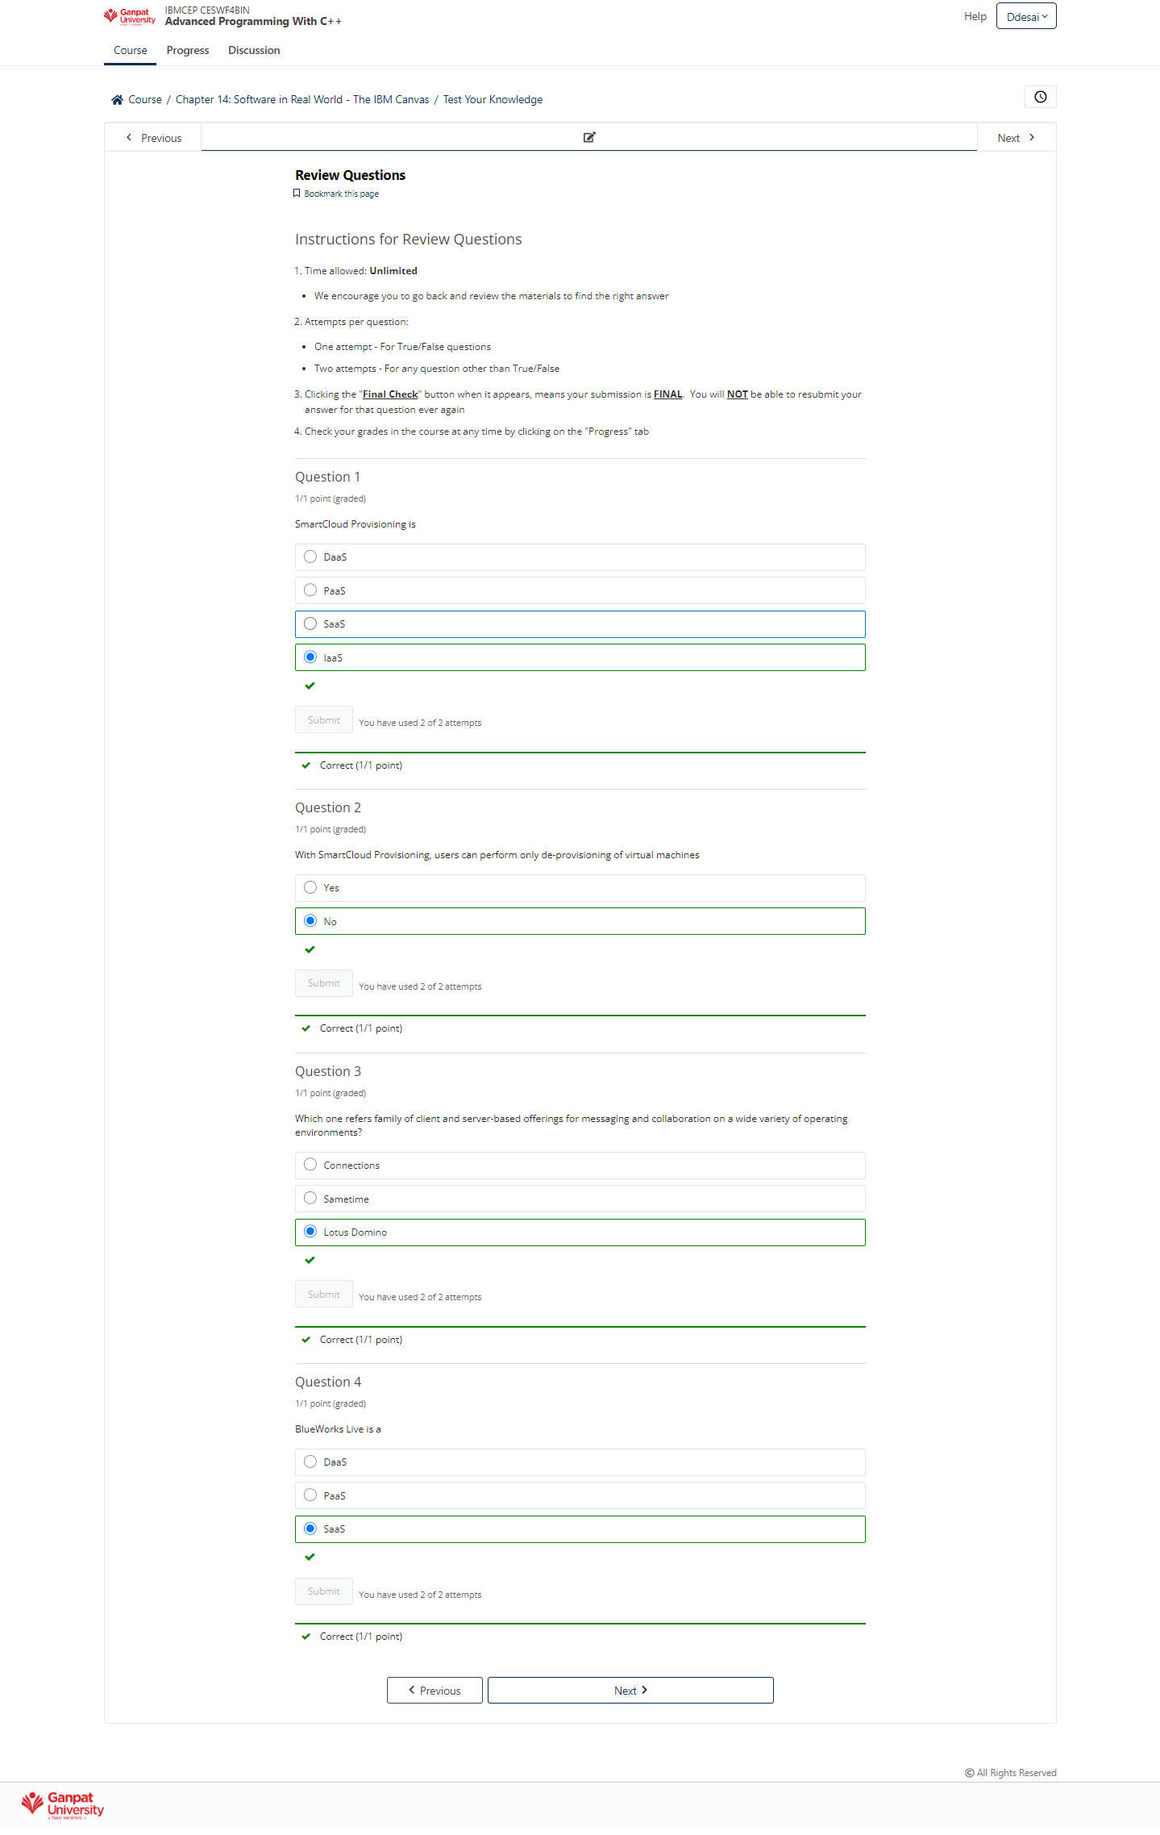

### **Chapter 15: Software in Real World- About Licensing**

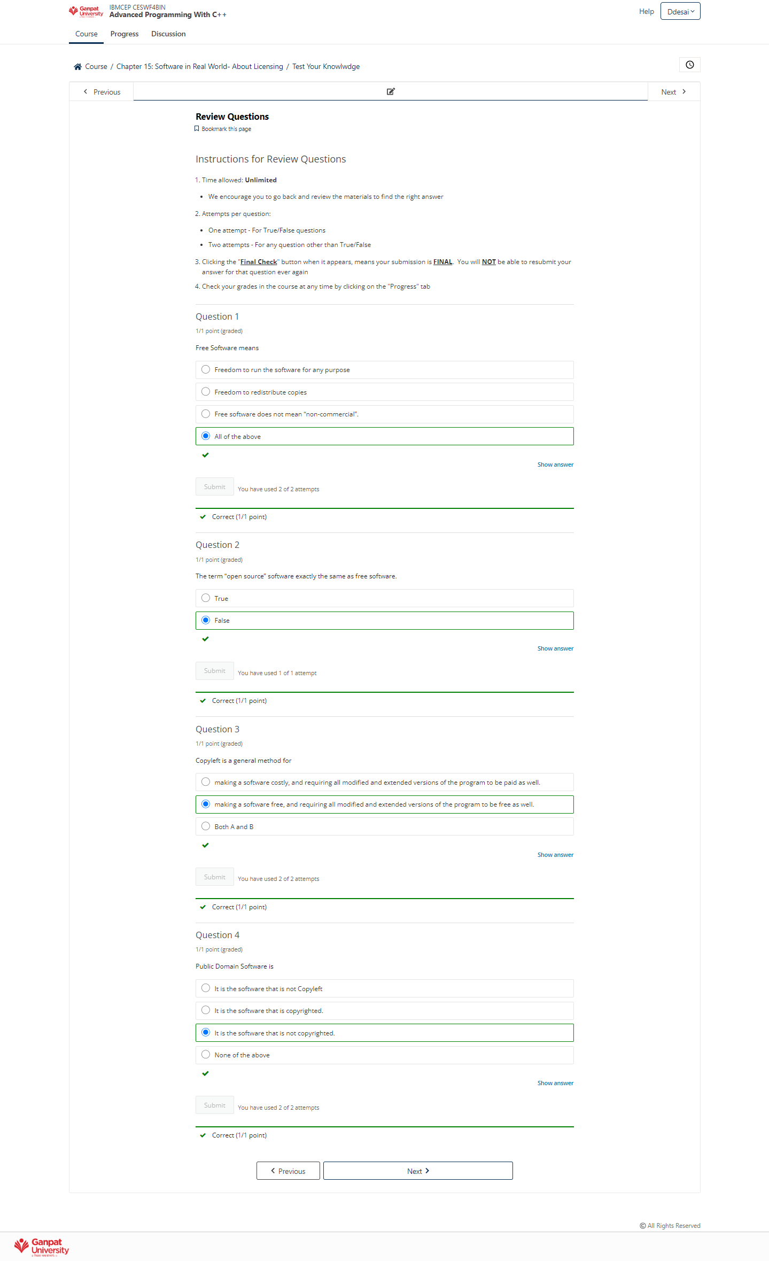

### **Chapter 16: Software in Real World - Road Ahead**

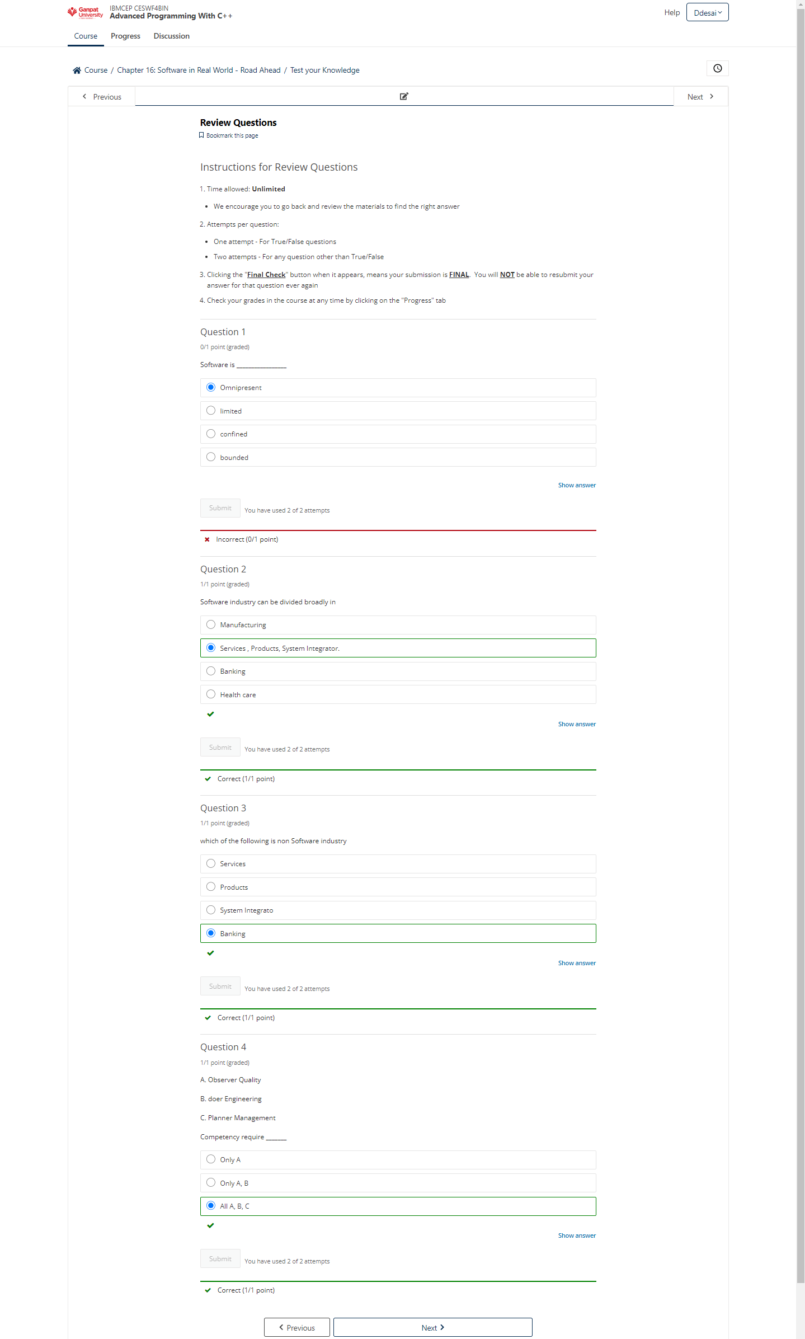

### **Final Exam**

